FOR IMMEDIATE RELEASE: 08 DECEMBER 2014

InnoVentum releases the new Giraffe design at PMQ - BODW in Hong Kong

Malmö, SWEDEN – InnoVentum has been invited to release the new Giraffe design at the heart of the PMQ courtyard during the prestigious Business of Design Week in Hong Kong – running from December 4-6 under the theme “Living Design”. The reception has been very warm so far:

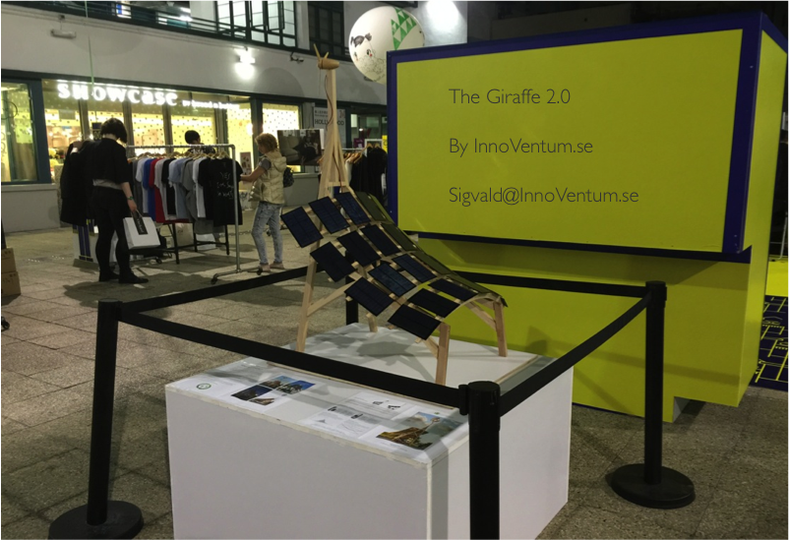

The Giraffe is the world’s most sustainable carport providing renewable energy to electric vehicles. Combining the energies of wind and sun – coupled with systematic use of wood for the structure – gives the Giraffe a CO₂ negative start: It has absorbed more than 4 tons of CO₂ through its renewable materials. For every year, it then delivers enough CO₂ neutral energy for two electric cars to drive around the Planet. Smart design gives the Giraffe a higher energy density than any other renewable energy carport on the market. No other solution delivers more than 13.000 kWh per year using less than 25 square meter space.

The Giraffe can do other things with its energy than charging EVs – it can for example power a pre-school while providing shade for the children playing underneath, or serve as a parking hub for 20 electric bikes. Not even imagination limits the types of applications of the Giraffe.

Using the iconic Turning Torso in Malmö as home base, it was natural for InnoVentum to connect with Santiago Calatrava and his Chief Designer, Mike Pfisterer, to co-create the new rounded design for optimal signal value of absolute sustainability – ready to decorate any city with strong ambitions in sustainability and passion for iconic design.

The Energy Agency of Sweden has awarded the Giraffe with a "Social Innovation Grant" for its pedagogical design bringing sustainability closer to people’s everyday lives - particularly suited for sustainability education of the younger generations. “The Giraffe through children’s eyes” was launched at this year’s InnoCarnival (a program run in collaboration between the cities of Hong Kong and Malmö) with 10 of more than 60 drawing contributions posted at: https://www.facebook.com/InnoVentum/photos/a.796075437118634.1073741838.204831216243062/796075670451944/?type=1&permPage=1

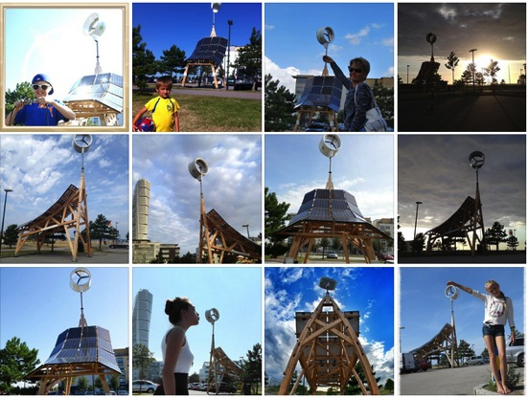

The first design of the Giraffe (in the photographs above – all made and posted by children) was installed at prestigious locations in Malmö in 2013 – such as Malmö Arena – the Eurovision Song Contest venue in 2013 – and the West Harbour next to the Turning Torso.

InnoVentum looks forward to continued mutually beneficial collaboration between Sweden and Hong Kong in the field of sustainability and innovations through appreciated collaboration with PMQ Management Co. Ltd, the Consulate General of Sweden to Hong Kong and Macao, the Hong Kong Trade Council and Swedish business promotion organisations such as Invest in Skåne, Royal Sweden Hong Kong Business Council and Business Sweden.

About InnoVentum
InnoVentum is a Malmö-based company developing and commercialising the world’s most environmentally friendly, resource-efficient and aesthetically compelling solutions for decentralised renewable energy production. In close collaboration with leading universities and design schools, we have developed and patent-protected small-scale renewable energy solutions. Our products have been installed in Sweden, Holland, France and the Philippines.
The company is co-owned by all employees and 33 angel investors. Website: www.innoventum.se

Contact
To learn more about InnoVentum’s presence at PMQ and BoDW.com and Investor Relations, please contact: Sigvald Harryson, CEO, +46 723 50 49 81, sigvald@innoventum.se

